**a**

**PROJECT REPORT ON**

**fingerprint based attendance system**

SUBMITTED TO SAVITRIBAI PHULE PUNE UNIVERSITY

FOR PARTIAL FULFILLMENT

OF THE REQUIREMENTS

for the award of the DEGREE OF

**BACHELOR OF ENGINEERING**

in

Electronics and Telecommunication Engineering

By

**MR. NEHAL BANDAL B120053019**

**MR. SANKALP GUPTA B120053069**

**MR. HEMANT DUKRE B120053072**

**GUIDE**

**Mr. ASHWIN BHANDEKAR**



**Department Of**

**Electronics and TELECommunication ENGINEERING**

**PUNE INSTITUTE OF COMPUTER TECHNOLOGY**

**PUNE – 43**

**2017-18**

Department of Electronics and Telecommunication Engineering

Pune Institute of Computer Technology, Pune – 43

CERTIFICATE

This is to certify that the Project Report entitled

**fingerprint based attendance system**

has been successfully completed by

MR. NEHAL BANDAL B120053019

MR. SANKALP GUPTA B120053069

MR. HEMANT DUKRE B120053072

Is a bona fide work carried out by them under the guidance of Dr. Y. Mr.Ashwin Bandekar and it is approved for the partial fulfilment of the requirement of the Savitribai Phule Pune University, Pune for the award of the degree of the Bachelor of Engineering (Electronics and Telecommunication Engineering). This project work has not been earlier submitted to any other Institute or University for the award of any degree or diploma.

Mr. Ashwin Bhandekar Dr. Y. Ravinder Dr. P.T. Kulkarni

Guide HOD, E&TC Dept Principal, PICT

Place: Pune

Date :

ACKNOWLEDGEMENTS

The completion of this project could not have been possible without the participation and assistance of so many people whose names may not all be enumerated. Their contributions are sincerely appreciated and gratefully acknowledged. However, the group would like to express their deep appreciation and indebtedness particularly to the following:

We express a deep sense of gratitude to Mr.AshwinBandekar (Project Guide)for their valuable guidance, keen interest, constructive criticism and encouragement at various stages in completion of this project.

Last but not least, we would like to express our gratitude to our friends and respondents for support and willingness to be there with us, to share their support, either morally, financially and physically, thank you.

Thanking You

Mr.NehalBandal

Mr.Sankalp Gupta

Mr.HemantDukre

CONTENTS

|  |  |  |  |
| --- | --- | --- | --- |
|  | Abstract | | 5 |
|  | List of Figures | | 6 |
|  |  | |  |
|  |  | |  |
| 1 | Introduction | | 7-11 |
|  | 1.1 | Background | 7 |
|  | 1.2 | Relevance | 8 |
|  | 1.3 | Literature Survey | 8 |
|  | 1.4 | Motivation | 9 |
|  | 1.5 | Problem Definition | 9 |
|  | 1.6 | Scopes And Objectives | 9 |
|  | 1.7 | Technical Approach | 10 |
|  | 1.8 | Organization of the Report | 11 |
| 2 | Attendance System Framework | | 12-16 |
|  | 2.1 | Introduction | 12 |
|  | 2.2 | Types of Attendance System | 12 |
|  | 2.3 | Hardware - Software Level Design | 13 |
|  | 2.4 | Attendance Management Approach | 14 |
|  | 2.5 | The Database | 15 |
| 3 | Fingerprint Recognition | | 17-21 |
|  | 3.1 | Introduction | 17 |
|  | 3.2 | Fingerprint Recognition Categories | 18 |
|  | 3.3 | How Fingerprint recognition works? | 18 |
|  | 3.4 | Overview of Fingerprint Sensor | 21 |
| 4 | System Performance and Evaluation | | 22-25 |
| 5 | Conclusion | | 26 |
|  | 5.1 | Project Outcomes | 26 |
| 6 | Future Plan | | 27 |
| 7 | References | | 28 |

ABSTRACT

Our project aims at designing a student attendance system which could executively manage attendance of students at institutes like PICT. Attendance is marked after student identification. For student identification, a fingerprint recognition based identification system is used. Fingerprints are considered to be the best and fastest method for biometric identification. They are secure to use, unique for every person and does not change in one's lifetime. Fingerprint recognition is a mature old to-day, but still identifying individual from a set of enrolled fingerprints is a time taking process. It was our responsibility to improve the fingerprint identification system for implementation on large databases e.g. of an institute or a country etc. In this project, many new algorithms have been used e.g. gender estimation, key based one to many matching, removing boundary minutiae. Using these new algorithms, we have developed an identification system which is faster in implementation than any other available today in the market. Although we are using this fingerprint identification system for student identification purpose in our project, the matching results are so good that it could perform very well on large databases like that of a country like India .

List of Figures

|  |  |
| --- | --- |
| Figure 1.1: | Classroom Scenario |
| Figure 2.1: | Hardware present in classrooms |
| Figure 2.2: | Lan Network |
| Figure 2.3: | ER Diagram(1) |
| Figure 2.4: | ER Diagram (2) |
| Figure 3.1: | Fingerprint Image |
| Figure 3.2: | Minutia diagram |
| Figure 3.3: | Bifurcation |
| Figure 3.4: | Termination |
| Figure 3.5: | Fingerprint Verification |
| Figure 3.6: | Internal Working of MFS 100 |
| Figure 4.1: | Table in Database |
| Figure 4.2: | Overview in Database |
| Figure 4.3: | Fingerprint in Database |
| Figure 4.4: | Homepage |
| Figure 4.5: | Attendance Update |
| Figure 4.6: | Report Generation |

CHAPTER 1

Introduction

Biometric Identification Systems are widely used for unique identification of humans mainly for verification and identification. Biometrics is used as a form of identity access management and access control. So use of biometrics in student attendance management system is a secure approach. There are many types of biometric systems like fingerprint recognition, face recognition, voice recognition, iris recognition, palm recognition etc. In this project, we used fingerprint recognition system.

# 1.1Background

Every organization whether it be an educational institution or business organization, it has to maintain a proper record of attendance of students or employees for effective functioning of organization. Designing a better attendance management system for students so that records be maintained with ease and accuracy was an important key behind motivating this project. This would improve accuracy of attendance records because it will remove all the hassles of roll calling and will save valuable time of the students as well as teachers.

Image processing and fingerprint recognition are very advanced today in terms of technology. It was our responsibility to improve fingerprint identification system. We decreased matching time by partitioning the database to one-tenth and improved matching using key based one to many matching

# 1.2 Relevance

Biometric Identification Systems are widely used for unique identification of humans mainly for verification and identification. Biometrics is used as a form of identity access management and access control. So use of biometrics in student attendance management system is a secure approach. There are many types of biometric systems like fingerprint recognition, face recognition, voice recognition, iris recognition, palm recognition etc. In this project, we used fingerprint recognition system.

# 1.3 Literature Survey

There proposed an embedded computer-based lectureattendance management system where a single-chipcomputer based subsystems (an improvised electronic cardand the card reader) were interfaced serially to the serialport of the digital computer. The electronic card is amodel of a smart card containing the student identity (ID Name, Matriculation Number and five pin encrypted code).The student ID is authenticated by the card reader which compares the entrance code with the encrypted code onthe card swiped through the card reader. The student isgranted and/or denies specific lecture attendance based onthe result of the comparison by the backend softwaresystem running on the PC to which the card reader isserially interfaced. The system though provided asimplified, low cost embedded computer based systemsolution to the management of lecture attendance problemin developing countries but does not eliminate the risk ofimpersonation. The system is devise-based in whichstudents have to carry RFID cards and also the RFIDdetectors are needed to be installed[7].

There proposed a real time computer vision algorithms inautomatic attendance management systems usingComputer vision and face recognition algorithms andintegrating both into the process of attendancemanagement. The system eliminates classical studentidentification such as calling student names, or checkingrespective identification cards, but still lacks the ability toidentify each student present in class thereby providing alower recognition rate because facial images are subject tochange between the time of enrolment and time ofverification and also poses a bigger financial burden duringinstallation and does not offer any privacy protection[8].In a wireless attendance management system basedon iris recognition was proposed using Daugman’salgorithm. The system uses an off-line iris recognitionmanagement system that can finish all the processincluding capturing the image of iris recognition,extracting minutiae, storing and matching but it is difficultto lay the transmission lines where topography is bad [9].

# 1.4 Motivation

Managing attendance records of students of an institute is a tedious task. It consumes time and paper both. To make all the attendance related work automatic and on-line, we have designed an attendance management system which could be implemented in PICT. It uses a fingerprint identification system developed in this project. This fingerprint identification system uses existing as well as new techniques in fingerprint recognition and matching. A new one to many matching algorithms for large databases has been introduced in this identification system.

# 1.5 Problem Definition

Designing a student attendance management system based on fingerprint recognition and faster one to many identifications that manages records for attendance in institutes like PICT.

# 1.6 Scope and Objectives

Manual attendance taking and report generation has its limitations. It is well enough for 30-60 students but when it comes to taking attendance of students large in number, it is difficult. For taking attendance for a lecture, a conference, etc. roll calling and manual attendance system is a failure. Time waste over responses of students, waste of paper etc. are the disadvantages of manual attendance system. Moreover, the attendance report is also not generated on time. Attendance report which is circulated over PICT webmail is two months old. To overcome these non-optimal situations, it is necessary that we should use an automatic on-line attendance management sys-tem. So we present an implementable attendance management framework. Student attendance system framework is divided into three parts: Hardware/Software Design, Attendance Management Approach and On-line Report Generation. Each of these is explained below.

# 1.7 Technical Approach

This part explains how students and teachers will use this attendance management system. Following points will make sure that attendance is marked correctly, without any problem:

1. All the hardware will be inside classroom. So outside interference will be absent.

(2)To remove unauthorized access and unwanted attempt to corrupt the hardware by students, all the hardware except fingerprint scanner could be put inside a small cabin. As an alternate solution, we can install CCTV cameras to prevent unprivileged activities.

(3) When teacher enters the classroom, the attendance marking will start. Computer software will start the process after inputting fingerprint of teacher. It will send the Subject ID, and Current Semester using the ID of the teacher or could be set manually on the software. If teacher doesn't enter classroom, attendance marking will not start.

(4) After some time, say 20 minutes of this process, no attendance will be given because of late entrance. This time period can be increased or decreased as per requirements.

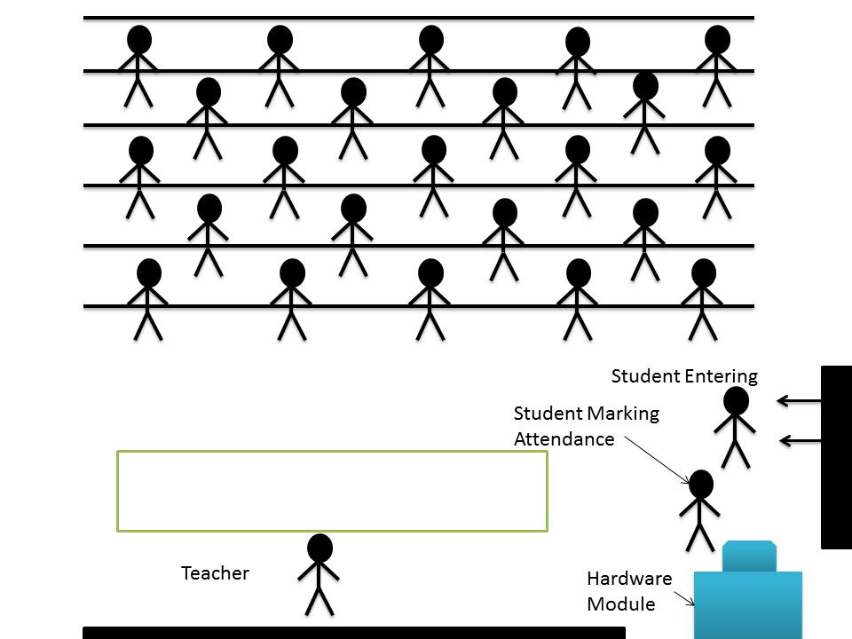

Figure 1.1: Classroom Scenario

# 1.8 Organization of Report

* Chapter 1 consists of brief introduction of the project and brief details of different aspects of project such as Problem definition, technical details, Literature survey etc.
* Chapter 2 consist of detailed explanation about project. This chapter explains the idea of project in detail and also discusses stuff related to it. It explains the structure of current attendance system. Also this explains the details about Remote attending system and compatibility of both systems. This chapter explains security features related to the project and database required for the project and their management.
* Chapter 3 shows how the fingerprint recognition system will work and it will cover the fingerprint template formation and its verification process.
* Chapter 4 contains the System Overview where the real time analysis of project is done.
* Chapter 5 contains the conclusion we got and the achieved project outcomes.
* Chapter 6 contains the future scope regarding the project.
* Chapter 7 contains the references used for the making of the project.

CHAPTER 2

Student Attendance Framework

2.1 Introduction

Every organization whether it be an educational institution or business organization, it has to maintain a proper record of attendance of students or employees for effective functioning of organization. Designing a better attendance management system for students so that records be maintained with ease and accuracy was an important key behind motivating this project. This would improve accuracy of attendance records because it will remove all the hassles of roll calling and will save valuable time of the students as well as teachers.

Image processing and fingerprint recognition are very advanced today in terms of technology. It was our responsibility to improve fingerprint identification system. We decreased matching time by partitioning the database to one-tenth and improved matching using key based one to many matching

2.2. Types of Attendance ManagementSystemAttendance Management falls into two categoriesnamely; Conventional and Automated methods.Conventional methods include time sheet, attendanceregister and time clock. Time sheets are documents,electronic or otherwise that record what time was spent bythe employee on what tasks. Attendance register is anofficial list of people who are present at an institution ororganisation. Time clock which is a mechanical (orelectronic) time piece used to assist in tracking the hourworked by an employee of a company.  
Automated methods include Barcode system attendancesystem, magnetic stripe attendance system, RadioFrequency Identification (RFID) and the biometric attendance system.  
The barcode attendance system requires that everyemployee is issued a badge/card in which there is abarcode. In order to check into or out of the company, thebadge/card is swapped on the time clock, and the data iscaptured by the clock. In the magnetic stripe attendance  
system, data is encoded in the magnetic stripe of theemployee card. When the card, is swiped through theemployee time clock, the information in the card’smagnetic stripe is recorded by the time clock. This systemreads one card at a time and also requires contact with thereader. Radio-frequency identification (RFID) is atechnology that uses radio waves to transfer data from anelectronic tag, called RFID tag or label, attached to anobject, through a reader for the purpose of identifying andtracking the object. The ID cards of the employees is  
embedded with RFID tag which is read by a reader. ThisRFID system is interfaced to a database through acomputer. Each employee uses an RFID card and thereader records the data when the employee enters or exits.  
In biometric Attendance system, there is attendancesoftware that is paired with a time clock for employeeswhich uses biometric technology for authenticationpurposes. When these systems are in use, the employeescan use their biometric data such as finger prints forclocking in and clocking out. This method has the greatbenefit that the entire process is easy as well as quick.Other advantages include elimination of the costpreviously incurred in getting the employees cards.

2.3 Hardware - Software Level Design

Required hardware used should be easy to maintain, implement and easily available.

Proposed hardware consists following parts:

(1)Fingerprint Scanner,

(2)Computer

(3) Internet

Fingerprint scanner will be used to input fingerprint of teachers/students into the computer software. PC will be displaying rolls of those whose attendance is marked. Computer Software will be interfacing fingerprint scanner and PC and will be connected to the network. It will input fingerprint, will process it and extract features for matching. After matching, it will update database attendance records of the students.

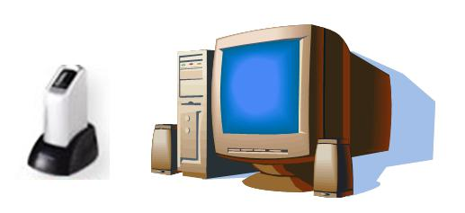

Figure 2.1: Hardware present in classroom

2.4 Attendance Management Approach

This part explains how students and teachers will use this attendance management system. Following points will make sure that attendance is marked correctly, without any problem:

1. All the hardware will be inside classroom. So outside interference will be absent.
2. To remove unauthorized access and unwanted attempt to corrupt the hardware by students.
3. When teacher enters the classroom, the attendance marking will start. Computer software will start the process after inputting fingerprint of teacher. It will send the Subject ID using the ID of the teacher. If teacher doesn't enter classroom, attendance marking will not start.
4. After some time, say 20 minutes of this process, no attendance will be given because of late entrance. This time period can be increased or decreased as per requirement.

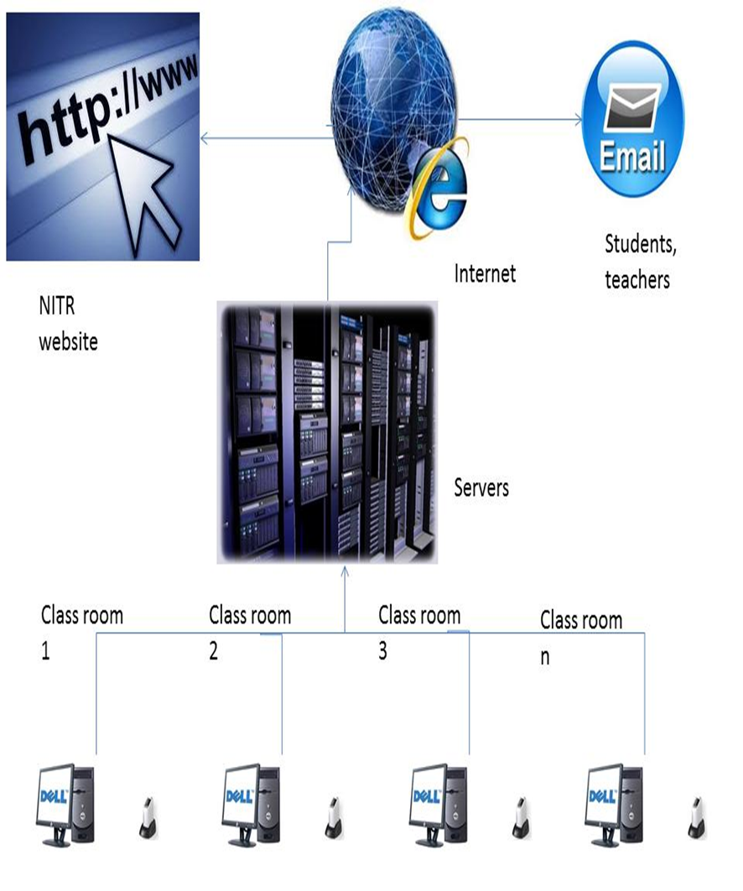

Figure 2.2: Lan Network

2.5 The Database

The attendance management system database consistsof tables that stores records, each of which corresponds toan authorized person that has access to the system. Eachrecord may contain the minutiae templates of the person’sfingerprint and Unique ID of the person as an index to the template.The database design for the system implements relationaldata model which is a collections of tables in which dataare stored. The database was implemented in MySQL database.MySQL is fastand easy, it can store a very large record and requires littleconfiguration.

The Entity relation diagram of the database is as shown below:

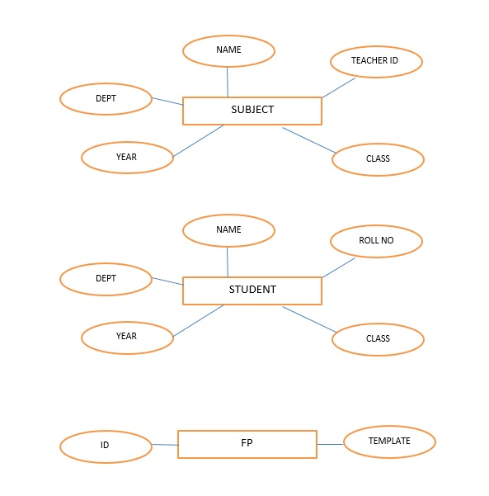

Fig:2.3 ER Diagram (1)

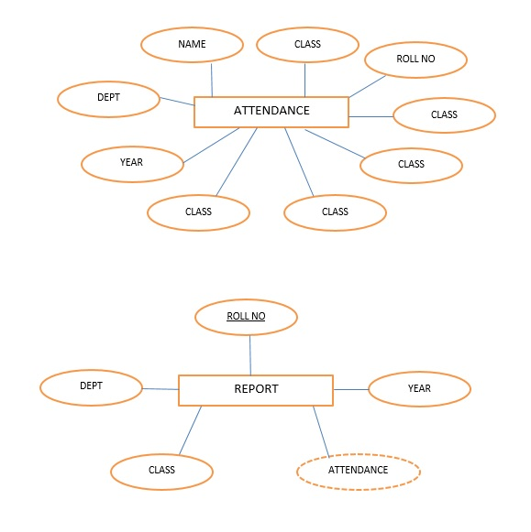

Fig: 2.4 ER Diagram (2)

CHAPTER 3

Fingerprint Recognition

3.1 Introduction

A finger prints are the most important part of human finger. It is experienced from the research that all have their different finger prints and these finger prints are permanent for whole life. So fingerprints have been used for the forensic application and identification for a long time.

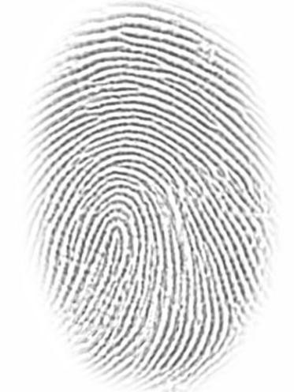

Figure :3.1Finger print image

A fingerprint is the composition of many ridges and furrows. Finger prints cannotbe distinguished by their ridges and furrows. It can be distinguished by Minutia, which are some abnormal points on the ridges.

Minutia is divided in to two parts such as: termination and bifurcation. Termination is also called ending and bifurcation is also called branch. Again minutia consists of ridges and furrows. Valley is also referred as furrow.

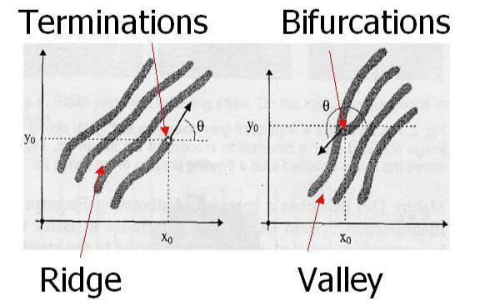

Fig:3.2 Diagram of Minutia

3.2 Fingerprint Recognition Categories

The fingerprint recognition problem can be grouped into two sub-domains such as:-

I) Fingerprint verification II) fingerprint identification

Fingerprint verification is the method where we compare a claimant fingerprint with an enrolee fingerprint, where our aim is to match both the fingerprints. This method is mainly used to verify a person’s authenticity. For verification a person needs to his or her fingerprint in to the fingerprint verification system. Then it is representation is saved in some compress format with the person’s identity and his or her name. Then it is applied to the fingerprint verification system so that the person’s identity can be easily verified. Fingerprint verification is also called, one-to-one matching.

Fingerprint identification is mainly used to specify any person’s identity by his fingerprint. Identification has been used for criminal fingerprint matching. Here the system matches the fingerprint of unknown ownership against the other fingerprints present in the database to associate a crime with identity. This process is also called, one-to many matching.

3.3 How Fingerprint Recognition Works?

**3.3.1 Fingerprint Template Formation / Minutia Extraction:**

**Pre-processingstage:-**

Pre-processing stage is divided in to three sub stages such as:-

i) Image enhancement ii) image binarization iii) image segmentation.

* Fingerprint image enhancement

It is used to make image clear for better use which is very easy to handle and can operate easily for further operation.

Here we used two methods for image enhancement stage those are:

1. Histogram Equalization
2. Fourier Transform.

Histogram equalization:-

Histogram equalization is mainly used to increase the pixel value of an image so that the perception information also increases.

Fourier transform:-

Here first of all we divide the image into different small processing blocks those are

of 32 by 32 pixels then use the Fourier transform according to formula:

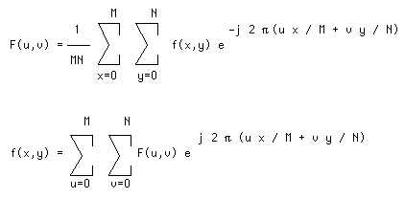

* Fingerprint image binarization:-

In case of image binarization we basically binarize the image by extracting the lightness of the image that is here we extract the brightness and density of the image as a feature amount from the image. When we select a pixel in an image, A sensitivity is added to it and it is subtracted from the Y value of the selected pixel because here we have to set the range of threshold value. Next, when a new pixel is selected again a new threshold value range is set which contains the calculation result and the previous threshold value. Then the pixel is extracted up to the same brightness whatever the selected pixel and the extraction result is displayed. Fingerprint Image Binarization is used to transform the 8-bit Gray fingerprint image to a 1- bit image and here the value for the ridges is 0 where as it is 1 for the furrows. After these operations, the ridges in the fingerprint will be highlighted with black colour while furrows will be colour with white.

* Fingerprint image segmentation:-

In case of segmentation we basically partition a digital image in to multiple segments that is a set of pixels, It also well known as super pixels. Our aim of the segmentation is to make the image simpler which can be represent very easily and to make the image meaningful so that it will be easy to analyse. Typically image segmentation is used to locate the objects and boundaries like the lines and curves present in an images. Generally, Region of Interest (ROI) is very much useful for recognizing each fingerprint image. The image area without effective ridges and furrows holds background information. So the effective ridges and furrows deleted first. Then the remaining effective area is sketched. Because the minutia present in that region are too much confusing with other duplicate minutia which are created when the ridges are out of the sensor.

**Minutia extraction:-**

After completing the enhancement and segmentation process now our job is to extract the minutia of the fingerprint image. The minutia extraction stage is divided in to two sub stages such as i) Ridge Thinning and ii) Minutiae Marking.

* Ridge thinning:-

The ridge thinning process is used to eliminate the redundant pixels of ridges till the ridges are just up to one pixel wide. Then the thinned image is filtered.

* Minutiae marking:-

After completion of fingerprint ridge thinning, minutiae marking is done by using 3 x3 pixel window as follows. In case of minutia marking the concept of Crossing Number (CN) is mainly used.

In 3 x 3 window if the central pixel is 1 and has exactly 3 one-value neighbours, then the central pixel is a ridge branch or bifurcation. i.eCn(p)=3 for a pixel “p”.

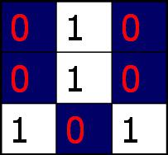

Figure 3.3 BIFURCATION

In 3 x 3 window If the central pixel is 1 and has only 1 one-value neighbour, then the

central pixel is a ridge ending or termination. I.e.Cn (p) =1 for a pixel “p”.

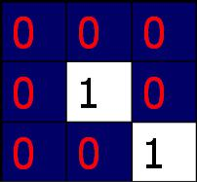

Figure 3.4 TERMINATION

**Storage of Fingerprint Template into Database:**

After image processing and extraction process, all the data will be stored in MySQL database. To store the database, a virtual server is required. The virtual server is used to deploy the database and website in a simulation environment before developing the actual web server. It is implemented by using XAMPP Control Panel V2.5 software to create a virtual machine.

The generated fingerprint template is encoded in ISOformat.ISO/IEC 19794-2 is an international fingerprint template standard standard that was created in order to achieve interoperability between different fingerprint recognition systems. In other words, it allows fingerprint templates generated by different vendors to be used in the same system for fingerprint enrolment and matching. This standard specifies the location and formatting of fingerprint minutiae template. Each template is in the range of 200 to 600 bytes.The generated ISO template is stored in ‘FP’ table of MySQL database along with the ID of the person.

**3.3.2 Finger print verification:**

Matching algorithm in verification process is 1:1.That means template of person who is to be verified is captured and it is compared with his/her previously stored template in database.

Following block diagram explains fingerprint verification process.

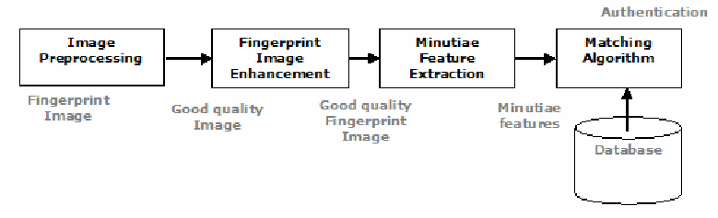

Fig: 3.5 Fingerprint verification

3.4 An Overview of Finger-Print Sensor

The fingerprint scanner module used in this project is MFS100.

MFS100 is high quality USB fingerprint sensor for fingerprint authentication for desktop or network security. MFS100 is based on optical sensing technology which efficiently recognizes poor qualityfingerprints also. MFS100 can be used for authentication, identification and verification functions thatlet your fingerprint act like digital passwords that cannot be lost, forgotten or stolen. Hard optical sensoris resistant to scratches, impact,vibration and electrostatic shock.

**Features of MFS100 are:**

* Lowest FAR and FRR.
* Plug and play USB 2.0 high speed interface supports multiple devices handling.
* 500 dpi optical fingerprint sensor scratch free sensor surface.
* Supports Windows 7,8,10, Windows Vista, Windows 2000, Windows Server 2003/2007/2008, Linux, Windows ME, Windows 98 SE SDK, Libraries and Drivers support across all above Platforms. (32 Bit and 64Bit)

**Specifications:**

* Fingerprint Sensor Optical (scratch free sensor surface)
* Resolution 500 DPI / 256 gray
* Sensing Area 16 x 18 mm
* Operation Temperature 0~50°C
* Standards ANSI-378, ISO19794-2
* Interface USB 2.0 High speed/Full speed, Plug & Play

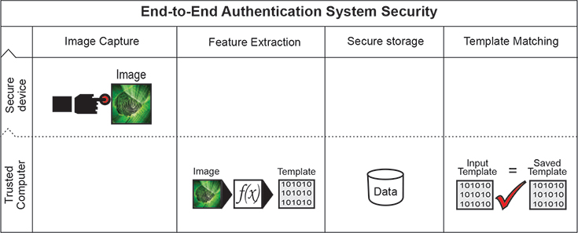

Fig: 3.6 Internal working of MFS100

Chapter 4

System Performance and Evaluation

We have tested our System in TE E&TC department. We have enrolled 47 students and 3 teachers. Attendance of the enrolled 47 students has been monitored in 3 Labs ( SPOS, ITCT, AP) of three different batches for 3 classes.

Following are the screenshots of the database and Project UI.

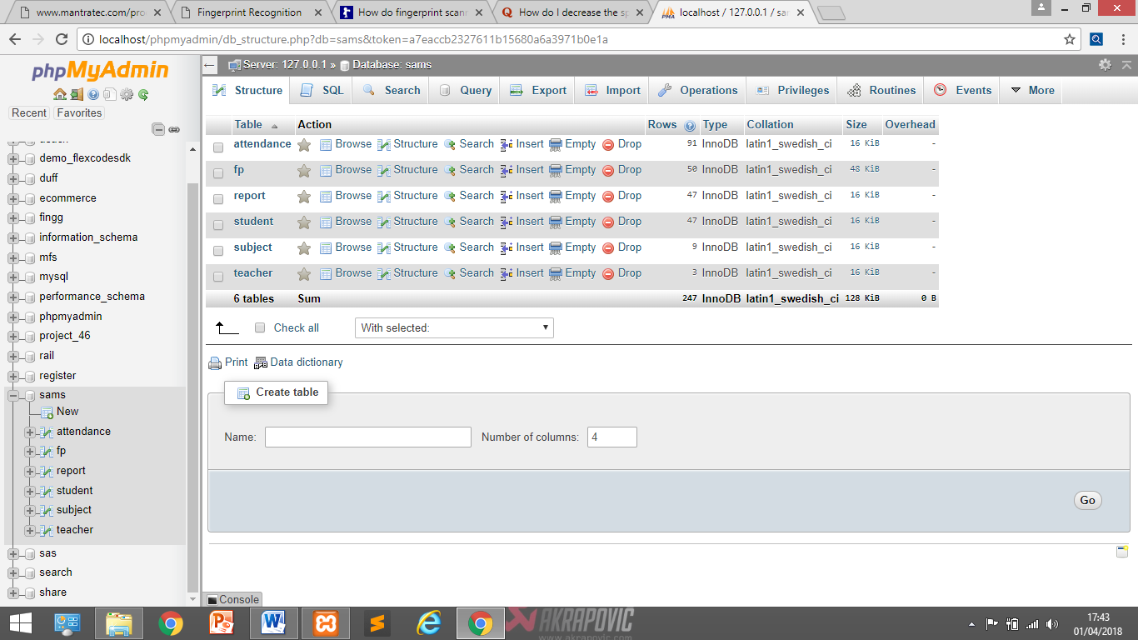

Fig:4.1 Tables in Database

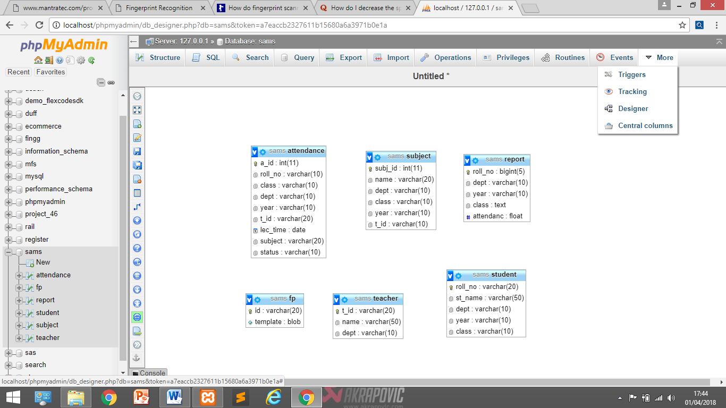

Fig: 4.2 Overview of Database

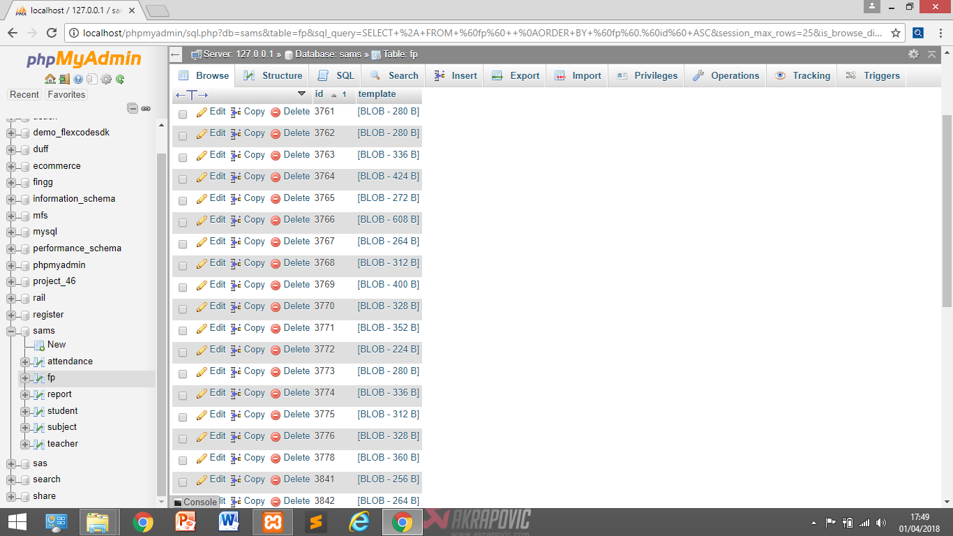

Fig: 4.3 Fingerprint template record in Database

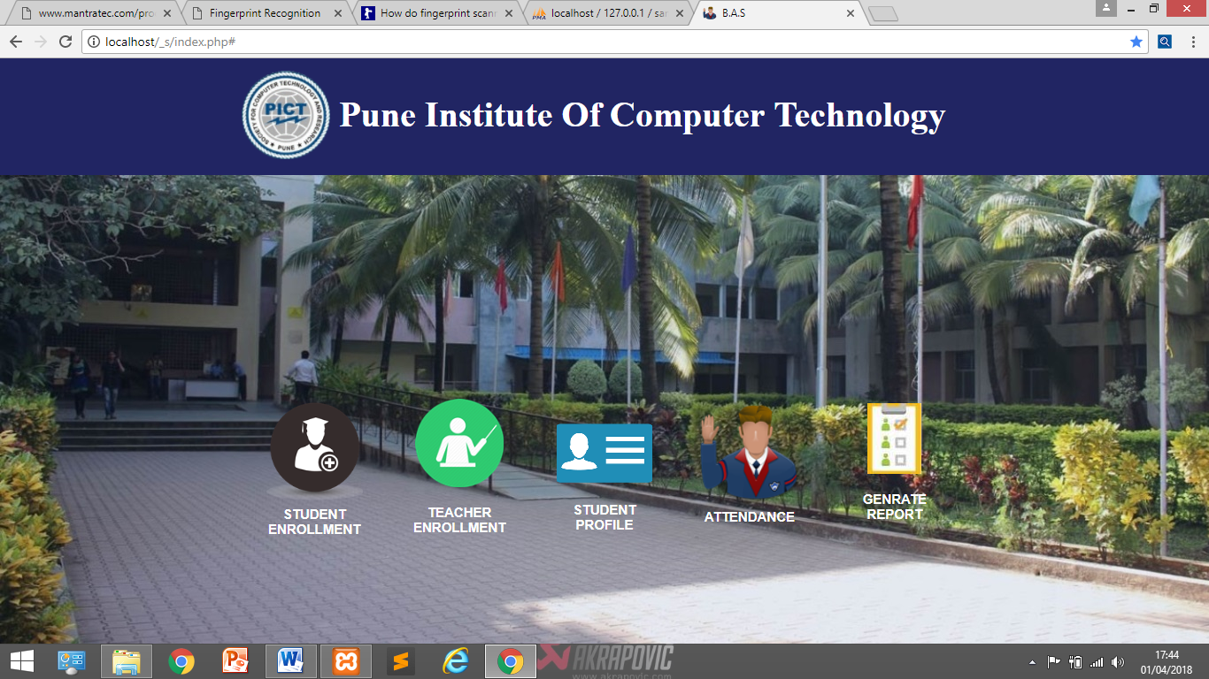

Fig: 4.4 Home page

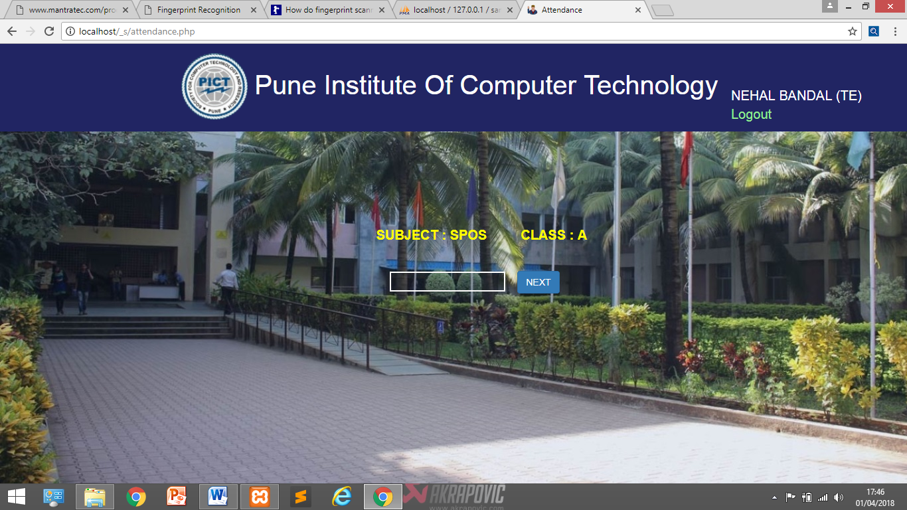

Fig: 4.5 Attendance Update

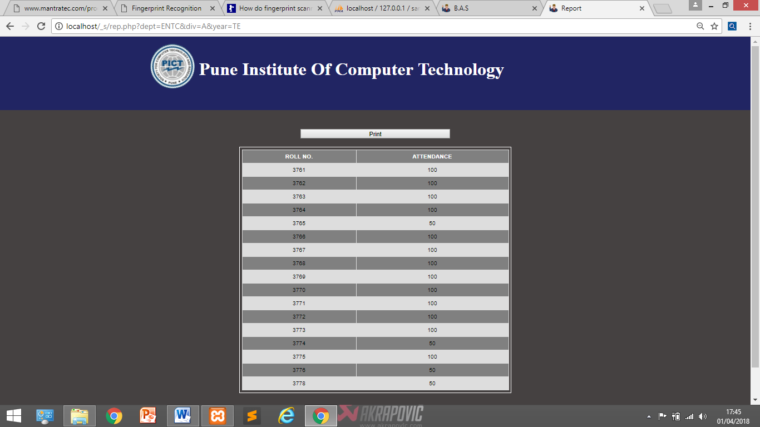

Fig: 4.6 Report Generation

Given a fingerprint matcher, one would like to assess its accuracy and speed performance in a realistic setting. Unlike passwords and cryptographic keys, biometric templates have high uncertainty. There is considerable variation between biometric samples of the same user taken at different instances of time. Therefore, the match is always done probabilistically. This is in contrast to exact match required by password and token based approaches. There are two important performance characteristics for biometric systems.

**False rejection** is the situation when a biometric system is not able to verify the legitimate claimed identity of an enrolled person.

FRR = (FR/N)*100

Where FR is the number of false reject and N is the total number of verification.

**False acceptance** is a situation when a biometric system wrongly verified the identity by comparing biometric features from not identical individuals.

FAR = (FA/N)*100

Where FA is the number of false accept and N is the total number of verification

**False Rejection Rate (FRR)** refers to the statistical probability that the biometric system is not able to verify the legitimate claimed identity of an enrolled person, or fails to identify an enrolled person.

**False Acceptance Rate (FAR)** refers to the statistical probability of false Acceptance or incorrect verification. In the most common context, both False Rejection and False Acceptance represent a security hazard.

In the test, the false acceptance rate was zero meaning that there were no cases of false acceptance (FAR) i.e. a person that was not pre-registered was not falsely enrolled  
for attendance. There were a few false rejections (FRR)during the test in which the system failed to identify some pre-registered users. These could be attributed to improper  
placement of the finger on the scanner and fingers that have been slightly scarred due to injuries.

|  |  |
| --- | --- |
| Total Successful Enrolment | 50 |
| Total No. of Attendee | 113 |
| Successful Verification | 111 |
| Unsuccessful Verification | 2 |
| Accuracy | 98.23% |
| FAR | 0 % |
| FRR | 1.77 % |

Table No:1Results of evaluation

CHAPTER 5

Conclusions

* This project mainly comprised if development of student attendance management system with the help of fingerprint verification system.
* We learnt about DBMS and have successfully installed XAMPP application on the PC.
* This project represents a framework using which attendance management can be made automated and on-line.
* We have designed and implemented database for attendance system using MYSQL.
* We have learnt fingerprint recognition process, based on minutia extraction of fingerprint image.
* The template generated in fingerprint recognition system is successfully stored and retrieved from database.
* The developed system is more efficient and time saving than the old traditional attendance taking method.

5.1 Project Outcomes

* We learnt about DBMS and have successfully installed XAMPP application on the PC.
* Most important database management language i.e. MySQL is studied and small database of different entities is implemented in MySQL.
* We have learnt about Web development and HTML to create the Webpages: Also, installing of apache server is studied and implemented successfully.
* An applicable attendance management system was designed for educational organizations. Ideas were presented for making whole system online using portable device
* Skills and self-confidence in coding and working with software's like Xampp Application were developed.

CHAPTER 6

Future Plan

* In future, this project can be implemented in labs as lab attendance system.
* This system can be developed for smartphones using android app.
* Android app based fingerprint attendance system can be used efficiently in lectures.
* In future, use of in-built fingerprint scanners of mobile can be used in this system.
* With some modification this system can be implemented in industry.

CHAPTER 7

References

1. <https://www.researchgate.net/publication/259973859_Fingerprint-Based_Attendance_Management_System>
2. <http://troikatrans.com/pdf/Mantra-MFS-100.pdf>
3. <http://ieeexplore.ieee.org/document/5754229/?anchor=authors>
4. files.spogel.com/abstracts/p-1661--Biometric_Fingerprint_Identification.doc
5. <https://www.w3schools.com/>
6. <https://www.mysql.com>
7. Shoewu O., Olaniyi O.M. and Lawson A. (2011): EmbeddedComputer-Based Lecture Attendance Management System.  
   African Journal of Computing and ICT. Vol 4, No. 3. P 27- 36,  
   September, 2011.
8. Shehu V. and Dika A. (2011): Using Real Time Computer VisionAlgorithms in Automatic Attendance Management Systems.  
   Proceedings of the ITI 2010 32nd Int. Conf. on Information Technology Interfaces, June 21-24, 2010, Cavtat, Croatia.
9. Kadry S. and Smaili M. (2010): Wireless Attendance ManagementSystem based on Iris Recognition. Scientific Research and EssaysVol. 5(12), pp. 1428-1435, 18 June, 2010.